**Institute of Information Technology (IIT)**

Jahangirnagar University



**Lab Report: 05**

Submitted by:

Name: Md. Shakil Hossain  
Roll No: 2023

Lab Date: 08/08/2023  
Submission Date: 18/08/2023

# Example 1:

**Lab Report # Day 05**

Apply logistic íegíession techniques to píedict CHD based on the píovided featuíes in the attached Dataset. (Given fíamingham.csv)

## Import Libraries & Read CSV File: Code:

import numpy as np import pandas as pd

import matplotlib.pyplot as plt import seaborn as sns

import math

%matplotlib inline

data=pd.read_csv("framingham.csv") data.head()

**Output:**

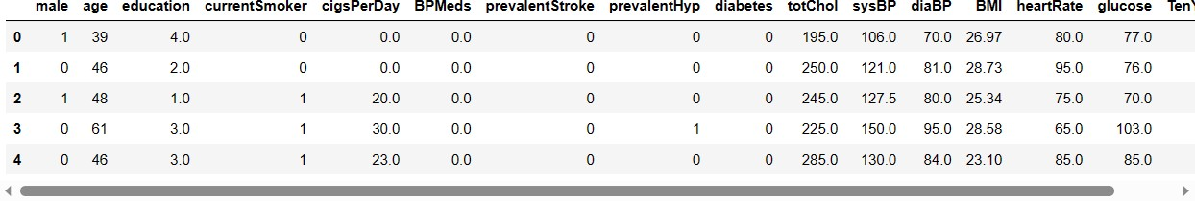

## Code:

sns.heatmap(data.isnull(),cmap='cividis')

**Output:**

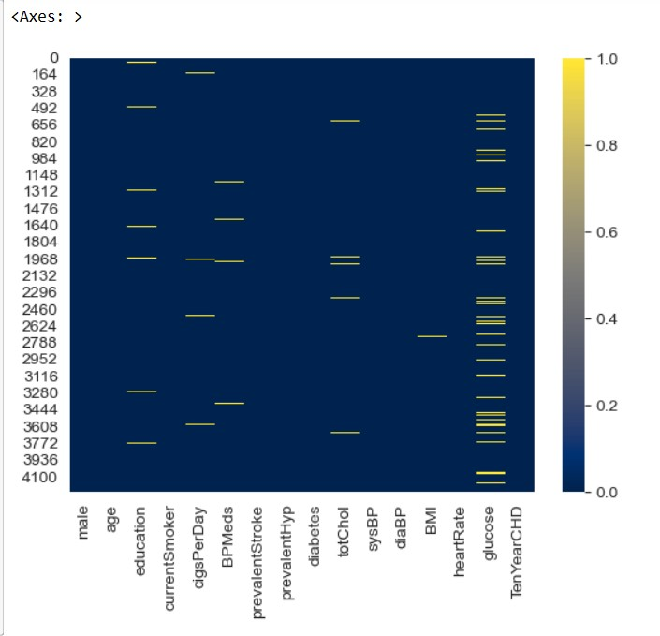

sns.countplot(x='TenYearCHD',hue='education’,data=data)

## Output:

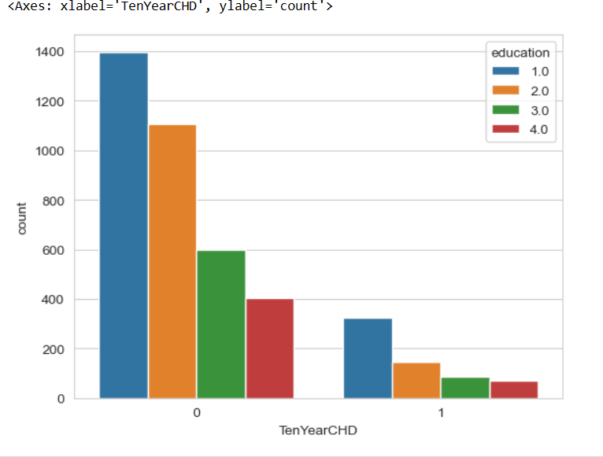

**Code:**

sns.countplot(x='TenYearCHD',hue='male',data=data,palette='RdBu_r')

## Output:

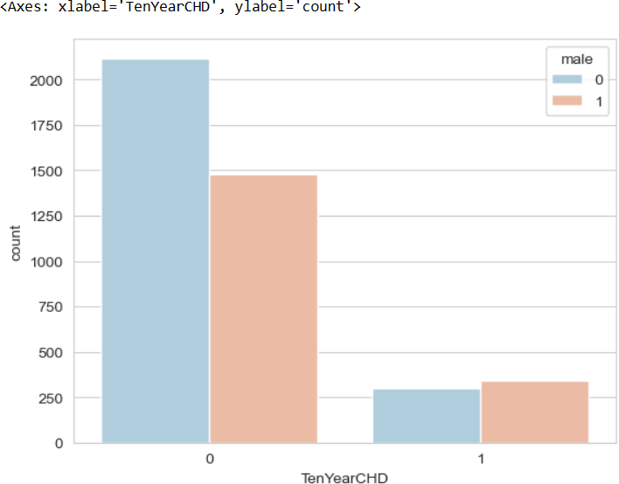

**Output:**

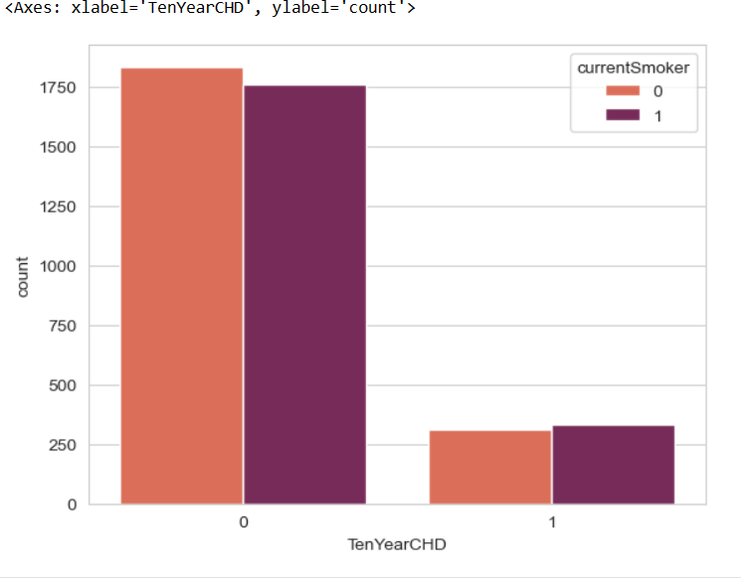

## Output:

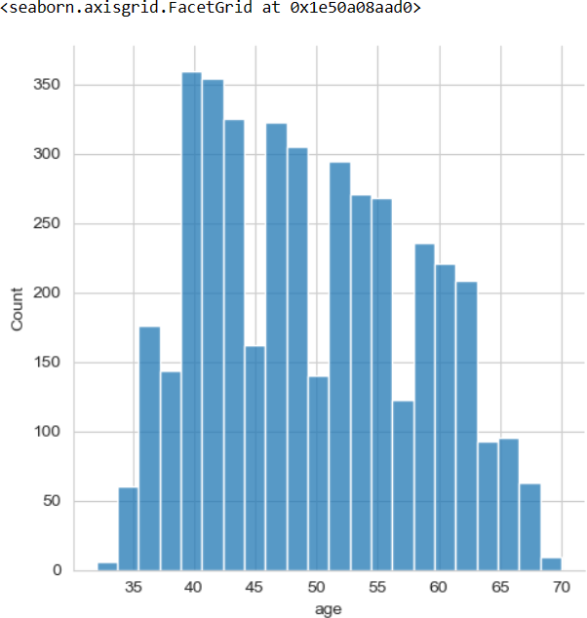

**Code:**

#**Function**

def fill_with_Data(cols): coloum=cols.keys()[0] female=cols[0] male=cols[1]

if pd.isnull(female): if male==1:

return math.ceil(data[data['male']==1][coloum].mean()) elif male==0:

return math.ceil(data[data['male']==0][coloum].mean())

else:

return female

*#***Clean Null Values**

data['education'] = data[['education','male']].apply(fill_with_Data,axis=1) data['cigsPerDay']=data[['cigsPerDay','male']].apply(fill_with_Data,axis=1) data['BPMeds']=data[['BPMeds','male']].apply(fill_with_Data,axis=1) data['totChol']=data[['totChol','male']].apply(fill_with_Data,axis=1) data['BMI']=data[['BMI','male']].apply(fill_with_Data,axis=1) data['heartRate']=data[['heartRate','male']].apply(fill_with_Data,axis=1) data['glucose']=data[['glucose','male']].apply(fill_with_Data,axis=1)

sns.heatmap(data.isnull(),cmap='cividis')

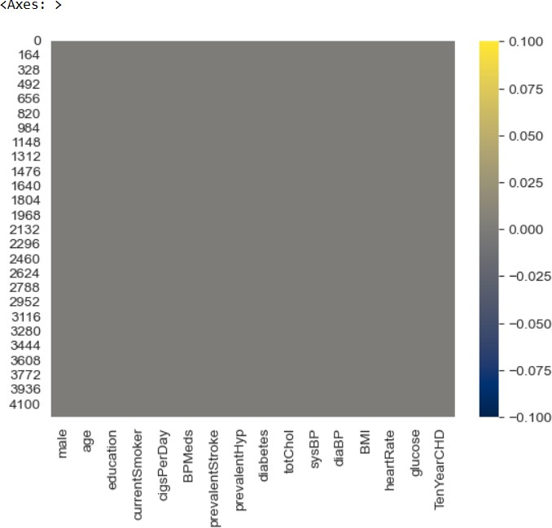

## Building a Logistic Regression Model: Code:

*#* **Train Test Split**

*from sklearn.model_selection import train_test_split x_train,x_test,y_train,y_test=train_test_split(data.drop('TenYearCHD',axis=1), data['TenYearCHD'], test_size=0.3, random_state=101)*

*from sklearn.linear_model import LogisticRegression lrmodel=LogisticRegression(solver='lbfgs',max_iter=1000) lrmodel.fit(x_train,y_train)*

**Output:**

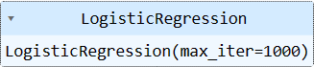

## Code:

**#Predicting** *predictions=lrmodel.predict(x_test) predictions*

**Output:**



## Evaluation: Code:

from sklearn.metrics import classification_report print(classification_report(y_test,predictions))

**Output:**

